# JavaScript Notes:--

* There are 7 fundamental data types in JavaScript: strings, numbers, booleans, null, undefined, symbol, and object.
* Numbers are any number without quotes: 23.8879
* We use the var, let, and const keywords to create variables.
* JavaScript is camel casing.
* Variable names cannot start with numbers.
* we should be aware of when using let (and even var) is that we can declare a variable without assigning the variable a value. In such a case, the **variable will be automatically initialized with a value of undefined**
* We can reassign the value of the variable, for var and let only.
* a const variable cannot be reassigned because it is constant
* In ES6, template literals use backticks ` and ${} to interpolate values into a string.
* Is equal to: ===
* Is not equal to: !==
* short-circuit evaluation.
* Ternary operator :- condition ? firstExpression : secondExpression
* non-empty strings are truthy!
* Another way of writing functions in JS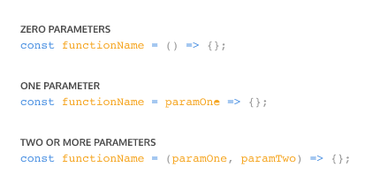
* A function body composed of a single-line block does not need curly braces. Without the curly braces, whatever that line evaluates will be automatically returned. The contents of the block should immediately follow the arrow => and the return keyword can be removed. This is referred to as implicit return.
* 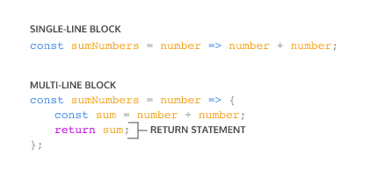
* const plantNeedsWater = day => day === 'Wednesday' ? true : false;
* here we have used ternary operator as well as the above single line function code

if condition is replaced with ternary operator and whole function is replace by line

const plantNeedsWater = (day) => {

  return day === 'Wednesday' ? true : false;

};

* Remember always round off your numbers in JS as they have different values sometimes.

to do that use .toFixed(decimalplace), but this gives string as output to convert again to number put “+” sign in beginning of the statement

if( + (1.1 + 1.3).toFixed(2) !== 2.4){

    showMessage('true');

 }

-> If function has no return value then it will show undefind on console.

Object and DOM

Object Properties

Square bracket and console.log both can be used.